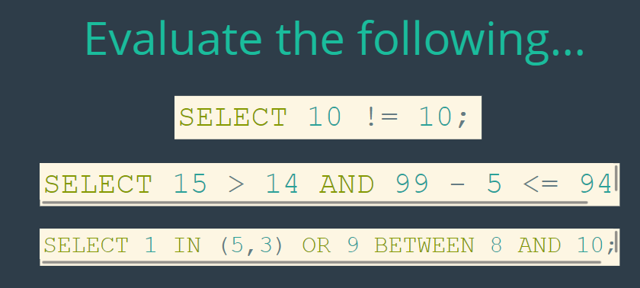











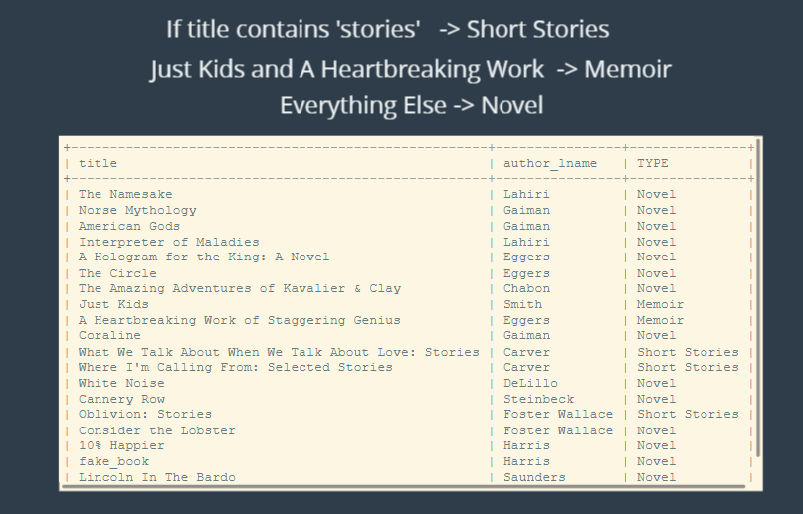

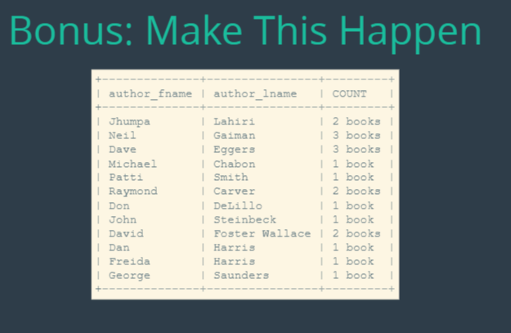

**The solutions:**

SELECT 10 != 10;

SELECT 15 > 14 AND 99 - 5 <= 94;

SELECT 1 IN (5,3) OR 9 BETWEEN 8 AND 10;

select * from books where released_year < 1980;

select * from books;

select * from books where author_lname = 'eggers' or author_lname = 'chabon';

select * from books where author_lname = 'lahiri' and released_year > 2000;

select * from books where pages between 100 and 200;

select * from books where author_lname like 'c%' or author_lname like 's%';

select title, author_lname,

case

when title like '%stories%' then 'Short Stories'

when title = 'just kids' or 'a heartbreaking work' then 'Memoir'

else 'Novel'

end as Type

from books;

select author_fname, author_lname,

case

when count(*) = 1 then concat(count(*), ' book')

else concat(count(*), ' books')

end as COUNT

from books

group by author_fname, author_lname;